EARN WHILE YOU LEARN
ASSIGNMENT-3

Q1.Design a HTML page with progress bar. After complete progress Bar page must redirect to an another HTML page.
Soln.
<!DOCTYPE html>
<html lang="en">
<head>
<meta charset="UTF-8">
<title>Progress Bar Page</title>
<style>
body {
font-family: Arial, sans-serif;
text-align: center;
padding-top: 100px;
background-color: #f0f0f0;
transition: opacity 1s ease-out;
}

#progressContainer {
width: 80%;
background-color: #ddd;
margin: auto;
height: 30px;
border-radius: 5px;
}

#progressBar {
width: 0%;
height: 100%;
background-color: #4caf50;
text-align: center;
line-height: 30px;
color: white;
border-radius: 5px;
transition: width 0.2s ease;
}

.fade-out {
opacity: 0;
}
</style>
</head>
<body>

<h2>Loading... Please wait</h2>
<div id="progressContainer">
<div id="progressBar">0%</div>
</div>

<script>
let width = 0;
const progressBar = document.getElementById("progressBar");

const interval = setInterval(() => {
if (width >= 100) {
clearInterval(interval);

// Fade out the page
document.body.classList.add("fade-out");

// Wait for the fade effect to complete before redirecting
setTimeout(() => {
window.location.href = "nextpage.html";
}, 1000); // 1s matches the CSS transition
} else {
width++;
progressBar.style.width = width + '%';
progressBar.innerText = width + '%';
}
}, 50); // Adjust speed (50ms for each 1%)
</script>
</body>
</html>
# This code is save in index.html
Output:-

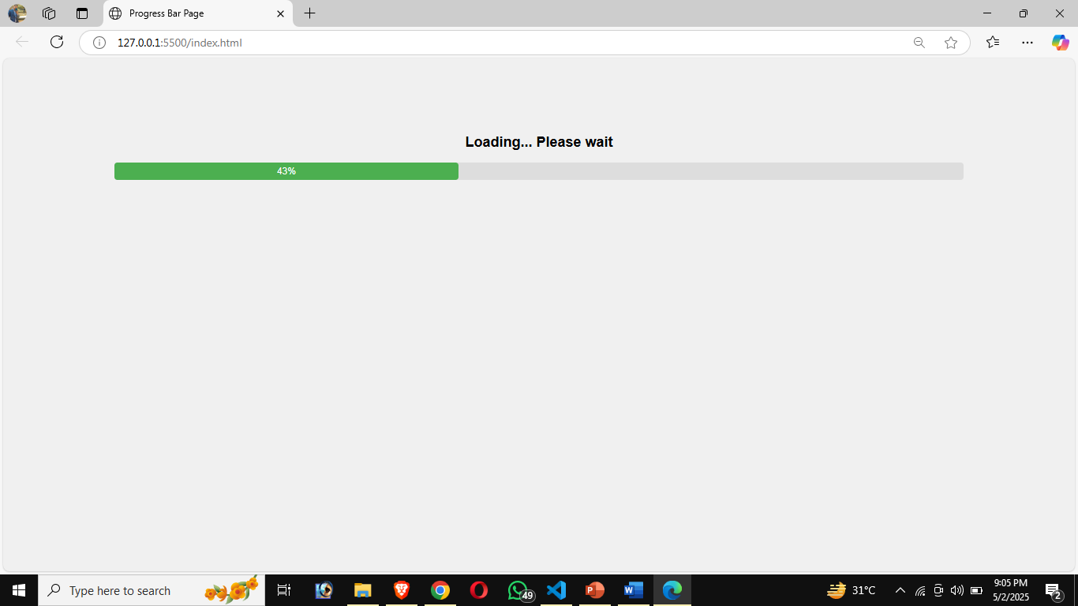

#for the next page, I save the code in nextpage.html
<!DOCTYPE html>
<html>
<head>
<title>Next Page</title>
</head>
<body>
<h1>You have reached the next page!</h1>
</body>
</html>
Output:-

